Colorado Eastern Plains Agriculture

Rangeland Monitoring to Inform Grazing Management in Eastern Colorado

**Technical Report**

Final - November 17th, 2022

Jillian Joubert

Sarah Hettema

Deni Ranguelova

TR Ingram

Max Stewart

***Advisors:***

Christopher Tsz Hin Choi (Colorado State University, Natural Resource Ecology Laboratory)

Dr. Paul Evangelista (Colorado State University, Natural Resource Ecology Laboratory)

Dr. Catherine Jarnevich (USGS, Fort Collins Science Center)

Dr. Anthony Vorster (Colorado State University, Natural Resource Ecology Laboratory)

Nicholas Young (Colorado State University, Natural Resource Ecology Laboratory)

***Fellow:***  
Sarah Hettema (Colorado)

# 1. Abstract

Adaptive management on cattle ranches requires rangeland managers to decide the location and duration of the cattle grazing activity across different pastures. Biodiversity, forage availability, and cattle health are all affected by rangeland management. Virtual fencing is a tool that rangeland managers can use to potentially increase biodiversity and improve ranching operations. NASA DEVELOP and Colorado State University (CSU) collaborated with the Nature Conservancy (TNC), and Red Top Ranch to demonstrate the efficacy of virtual fencing. We sought to identify annual and monthly biomass patterns on the ranch through the creation of monthly max biomass productivity maps. We utilized a dataset from the Agricultural Research Service (ARS) to calculate biomass on the ranch. To validate our remotely-sensed results, we compared model-predicted biomass values to field-collected biomass clipping data and an additional biomass dataset from the Rangeland Analysis Platform (RAP). We used satellite imagery from Landsat 5 Thematic Mapper (TM), Landsat 7 Enhanced Thematic Mapper Plus (ETM+), Landsat 8 Operational Land Imager (OLI), Landsat 9 –OLI-2, and Sentinel-2 MultiSpectral Instrument (MSI) for 2021 and 2022. We found that there was heterogeneity in biomass across the ranch, with higher biomass on the western side. The highest peak of biomass was in the summer months, with a smaller peak in mid-September. The ARS biomass dataset had a significant relationship with RAP for 2021. ARS biomass did not have a significant relationship with the biomass field data collected in 2022. The results of our study are aimed to support rotation management, ranch production, biodiversity, and conservation management.

**Key Terms**

cattle, rangeland, biomass, bare ground, virtual fencing, conservation, Colorado

# 2. Introduction

Virtual fencing is currently being trialed as an emerging technology for effective adaptive rangeland management. This technology involves the use of trackable collars placed on cattle, which are linked to virtual maps that set boundaries for where cattle can graze (Campbell et al. 2021). When cattle approach the virtual fence, the collar sends auditory stimuli to warn them before administering a shock if they pass the limit. This allows rangeland managers to herd their cattle remotely, improving management efficiency. Virtual fences can also be used to improve rangeland biodiversity, create fuel breaks for wildfire prevention management and provide riparian buffer protection (Boyd et al. 2022). The health of livestock grazing in the West is vital to exurban development, public recreation, and cultural vitality. Privately owned rangelands provide ecologically diverse landscapes, economically impactful local goods, and a unique cultural identity. Without this resource, those benefits would either disappear or be completely altered (Knight 2009). In support of rangeland management, studies are emerging that focus on using remote sensing tools to give information to aid management decisions.

Recent studies have used remote sensing to observe patterns of biomass growth annually in rangeland environments. Several models were tested that incorporated Visually-Observed (VO) field-collected biomass measurements in conjunction with satellite imagery to develop biomass models. The Agricultural Research Service (ARS) developed a biomass model that was based on the Central Plains Experimental Range (CPER) in northern Colorado rangeland data and incorporated potential disturbance factors (Kearney et. al, 2022). The Rangeland Analysis Platform (RAP) developed biomass models that were based on a broader region that calculated above ground biomass at 16-day intervals, which are summarized annually and don’t include the accumulation of biomass (Jones et al. 2021, Robinson et al 2019). New advances in remote sensing technology have led to increased analysis capability among products derived from said platforms. Application of this capability has extended to the quantification of rangeland biomass production as a foundational ecosystem service (Jones et al., 2021). This type of data is extremely versatile in its use, aiding the adaptive management process within an effective spatio-temporal scale (Kearney et al. 2021). We conducted an analysis summarizing, evaluating, and comparing the ARS and RAP biomass models for the Eastern Plains of Colorado at Red Top Ranch, where virtual fencing is currently being trialed.

For this study, we partnered with Red Top Ranch, the Nature Conservancy, and Colorado State University. Rangeland managers at Red Top Ranch were interested in learning more about biomass production patterns across their land and if virtual fencing can better manage their cattle and resources. They utilized maps and data to inform decision making on grazing rotations, improving their land management and the available feed for the cattle. The Nature Conservancy was interested in improving biodiversity in the region that would benefit not only the vegetation but also avian species' habitat. Colorado State University is collaborating with the NASA DEVELOP National Program to utilize remote sensing to understand the effects virtual fencing has on rangeland management, and the potential of this new technology.

Red Top Ranch is located in Southeastern Colorado, in what was formerly known as the “Dust Bowl region” (Figure 1). The ranch comprises roughly 80,000 acres of grassland habitat. This area is known for its loamy, dry soils, periodic fire events, and periodic drought conditions. The dominant plant species within this landscape are blue grama (*Bouteloua gracilis*), James’ galetta (*Pleuraphis jamesii*), and western wheatgrass (*Pascopyrum smithii*) (Ecological Site Description, 2005). The species composition of this area is 75-90% grasses, with some forbs, shrubs and woody plants comprising the remainder of biodiversity. These features make the landscape ideal for cattle grazing and this region has coevolved with grazers within the ecosystem. This study focused on ten pastures in Red Top Ranch, five experimental and five control pastures. All cattle (excluding calves) had virtual fencing collars on them, but only the experimental herds had their collars activated. In the experimental pastures, the cattle are actively being managed through virtual fencing methods. The impact of this new management method on the landscape’s biomass availability was compared to previous years of biomass availability before the virtual fencing methods were implemented.

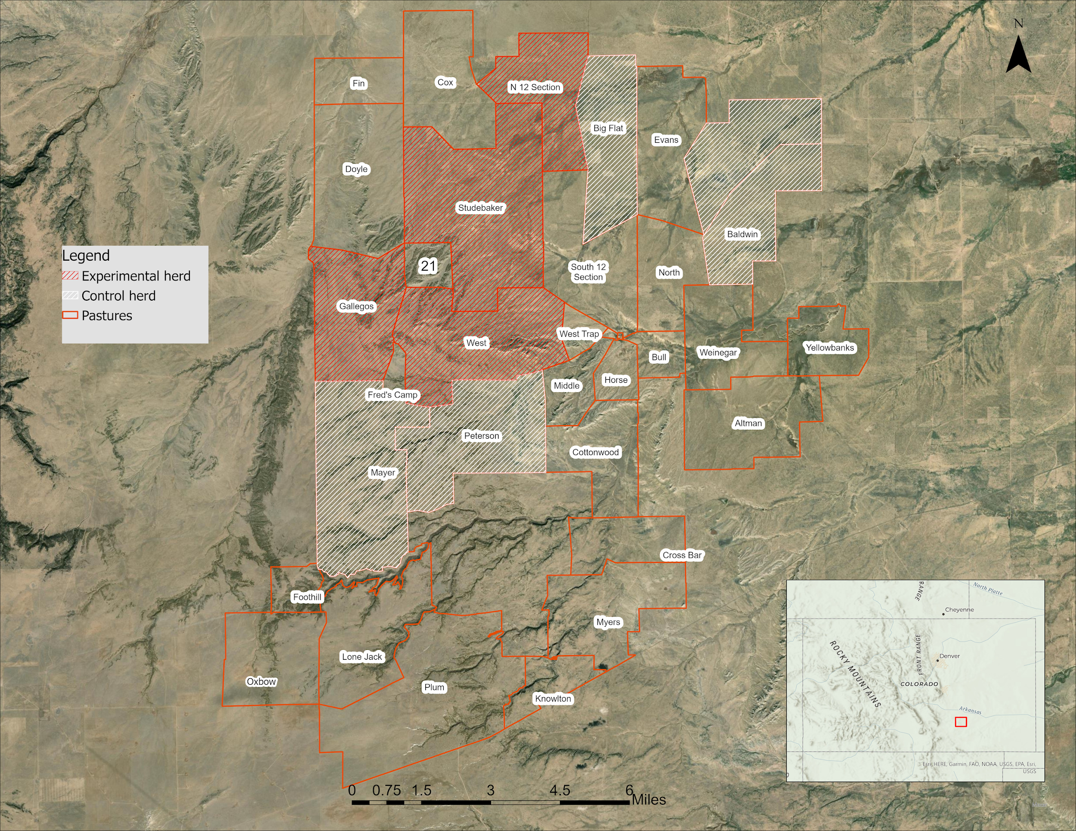

*Figure 1.* Study Area map of Red Top Ranch. Red polygons are experimental pastures and white are the control pastures. Base map is from ESRI.

# 3. Methodology

***3.1 Data Acquisitions***

This study used biomass data from the ARS and RAP (Table 1). We acquired 2021 and 2022 daily biomass data from the ARS (Kearney et. al, 2022). ARS biomass data was developed to model daily biomass in northern Colorado (Central Plains Experimental Range), which consists of mostly grasslands with little shrub or tree cover. The team at ARS applied this biomass model which uses Landsat 8 OLI and Sentinel-2 MSI harmonized data, to the Red Top Ranch study allowing the DEVELOP team and the greater collaborative project to monitor the landscape using remote sensing. The 2022 data ranged from January 1st, 2022 - October 15th, 2022, due to the timing of the team’s analysis in October 2022. Additional biomass data was sourced from RAP and represents the accumulated biomass throughout the year (Jones, 2021). RAP is available across the Western U.S. and utilizes a combination of Landsat 5 TM, Landsat 7 ETM+, and Landsat 8 OLI data.

The Evangelista Lab, based out of Colorado State University’s Natural Resource Ecology Laboratory, collected field biomass data during the summer of 2022. Robel poles were used to quantify the density and volume of vegetation for 28 plots. Plots were 60 meters by 60 meters in the representative areas. 50 meter transect tapes were laid out and Robel pole measurements were taken every 5 meters for a total of 11 Robel points per transect with three transect per plot. Two readings per point were taken, one east and one west. All readings were averaged together for a single plot to provide an average high and low VO reading that is used to relate to the amount of biomass at the plot. An additional, 14 plots were placed consisting of two transects each where VO readings were taken and all above ground biomass within a 50 x 20 cm subplot were clipped to measure the biomass. A relationship between these two measurements (VO and biomass) was developed and applied to all the 28 plots to estimate biomass in kg/ha.

Our partners at Red Top Ranch provided us with the GPS locations of infrastructure around the ranch. We used infrastructure data to interpret biomass production across the landscape. We acquired Existing Vegetation Type and Existing Vegetation Cover data from the LANDFIRE online database (Robinson, 2019). These vegetation layers classify land cover by vegetation types using field data, Landsat imagery, elevation, and biophysical gradient data.

**Table 1**

*Summary of data used in analysis including data type, source, resolution, dates and use.*

|  |  |  |  |  |
| --- | --- | --- | --- | --- |
| ***Data Type*** | ***Sourced from*** | ***Resolution*** | ***Dates*** | ***Use*** |
| **Biomass Raster Imagery** | Agricultural Research Service (ARS) | 30 m | 2021-2022 | Rasters used for biomass production model comparison |
| **Biomass Productivity Raster Imagery** | Rangeland Analysis Platform (RAP) | 30 m | 2021 | Rasters used for biomass production model comparison |
| **Biomass Visually Observed (VO) Field Data** | Colorado State University | n/a | Summer 2022 | To validate ARS model |
| **Red Top Ranch Infrastructure GIS Locations** | Red Top Ranch | n/a | Current as of 2021 | To summarize and interpret maps of rangeland production and condition |
| **LANDFIRE Existing Vegetation Type (EVT) and Existing Vegetation Cover (EVC)** | LANDFIRE online database | n/a | 2016, updated 2020 | Existing Vegetation Type (EVT) layer consists of vegetation cover types that are on the ranch. Existing Vegetation Cover (EVC) was used to observe tree canopy cover percentage on the landscape. Both layers were used to find timber stands and other vegetation distributions that create extremely high biomass values. To develop a mask, this data was utilized to separate extremely high biomass areas from raster analysis |

***3.2 Data Processing***

***3.2.1 Initial Biomass Comparison***

Using the standing biomass data from ARS, we used RStudio to calculate the maximum biomass availability on the landscape in 2021 and 2022. These calculations were summarized by year and by month for both years. The ARS raster dataset contained 365 bands, one for each day of the year. We used RStudio to create a new raster containing only the maximum biomass value of the year for each pixel. After observing patches of extremely high biomass in the ARS data, we determined that larger, more dense vegetation such as Juniper trees and cholla cacti was likely causing these high spikes.

***3.2.2 LANDFIRE EVT and EVC Analysis***

We used EVT and EVC data to examine which vegetation communities were present within our study area. We converted the raster datasets into polygon layers using ArcGIS Pro version 3.0.2 and calculated the area of each cover class type and the percentage of the ranch it encompassed. We then used the zonal statistics tool on the ARS and RAP datasets using these polygons to calculate the minimum, maximum, and mean biomass values within each vegetation type. The RAP raster dataset has two bands - Band 1 represents annual vegetation and Band 2 represents perennial vegetation. To get a raster that encompasses the total biomass present for 2021, we used the raster calculator tool to add the two together. The min, max, and mean calculations were then derived from this new raster.

After looking at the biomass summary statistics separated by vegetation type, we noticed that the highest biomass values in the data were present in tree and shrub categorized vegetation types. We decided to exclude these areas from our analysis because they inaccurately skewed the biomass numbers, and for this study we focused on the grassland vegetation present on the landscape. After researching which specific species were included in the EVT vegetation categories, we decided to only include two of the classified vegetation types - Western Great Plains Shortgrass and Prairie Western Great Plains Foothill and Piedmont Grassland. These two vegetation types comprised 90% of the area within Red Top Ranch (Figure 2). We created a raster that included only the two grass types of interest and created a script using RStudio version 2022.07.1 to mask out all other vegetation types for the ARS data. The masked-out values were converted to NA values so that they could be fully excluded from any statistical analyses. We then created a second mask that clipped the biomass data down to the ranch boundary.

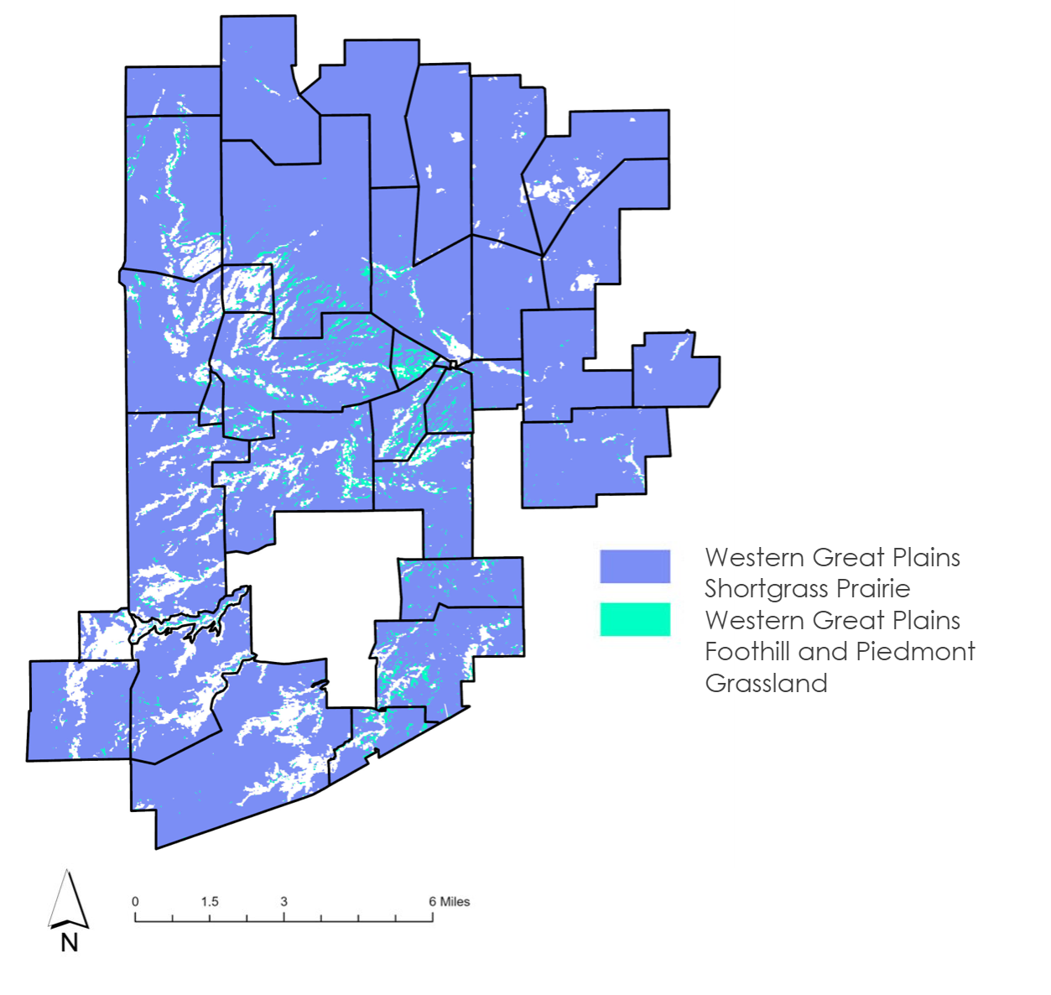*Figure 2.* Map of Western Great Plains Shortgrass Prairie and Western Great Plains Foothill (purple) and Piedmont Grassland (turquoise). All other vegetation types were not included and are shown in white within the ranch boundary.

In addition to masking out unwanted vegetation types, we limited the date range for analysis to the growing season in Colorado. During our initial data exploration, we observed unusually high biomass values (over 8000 kg/ha) during the beginning and end of the year (Figure 3). The unreasonably high biomass values in the winter months are likely due to the ARS model’s limited ability to handle snow on the landscape and seasonal weather patterns but was not verified at this time. We decided to limit the date range to day of year (DOY) 91 (April 1) through DOY 274 (October 1) to correspond with the growing season and remove the high biomass values.

*Figure 3.*  Scatter plot showing day of year of max biomass and the count. Red lines show where the date range was limited to day of year (DOY) 91 (April 1) through DOY 274 (October 1) to correspond with the growing season and remove the high biomass values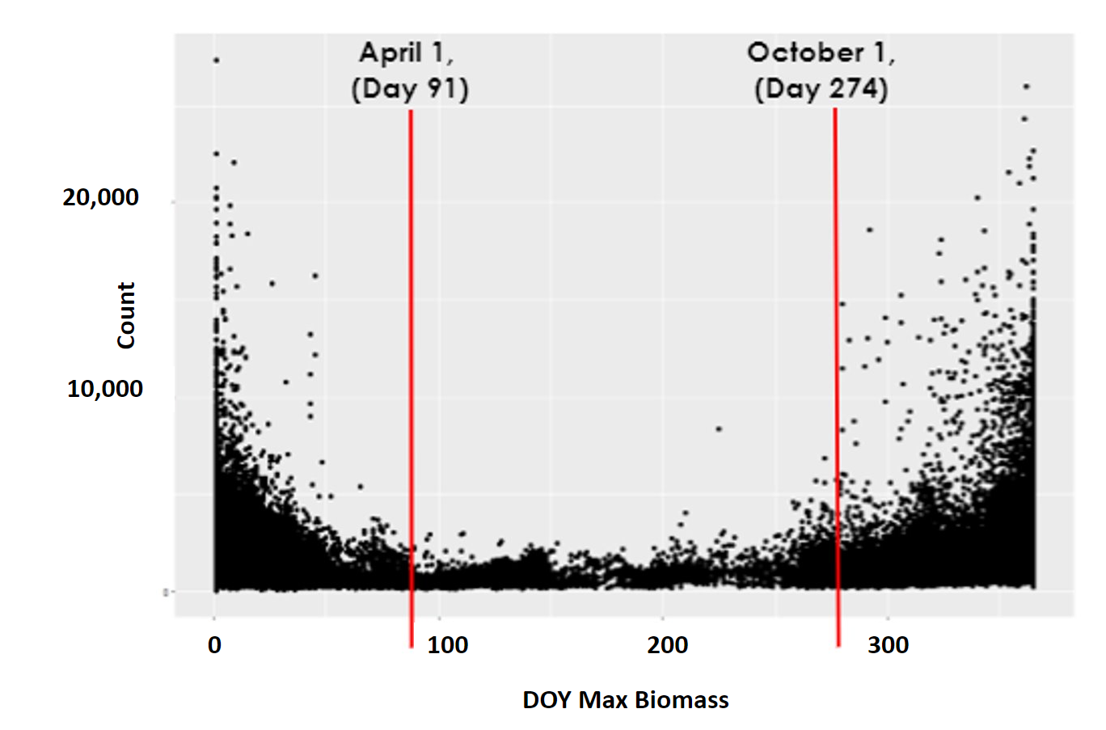

***3.3 Data Analysis***

We created maps and histograms of the maximum biomass values for each pixel within the pasture boundary for 2022, using the ARS biomass data in RStudio. We created annual and monthly max biomass maps for the growing season. Using the same data, we created another map that displayed the date of the max biomass value of each pixel to further investigate potential spatial and temporal patterns in vegetation growth and decline throughout the year.

We compared the visually-observed field data of biomass collected in the summer of 2022 to the daily ARS biomass predictions by extracting the ARS biomass value using the coordinates of the field sites and matched the DOY to the date that the field data was collected. This was used to validate the ARS biomass calculations. To compare ARS and RAP biomass products we first calculated the mean ARS biomass value per pixel. We reprojected these layers to align them to the same coordinate reference system. Next, we merged the data frame to remove null values and randomly sampled 10,000 points within the ranch boundary. From this data, we created a density plot comparing ARS and RAP. Mean annual biomass for the ARS data was plotted against the annual biomass values for the RAP data. The purpose of this comparison was to see if there was a relationship between them, and if both have similar suitability to the study area landscape.

The annual max raster that had the vegetation mask applied was brought into ArcGIS Pro and zonal statistics were performed to calculate total annual biomass for the experiment and control pastures. We then compared the total annual biomass for max pixel values for each of the pastures of interest (Figure 6b). This process was done for monthly max biomass values as well and were visualized in monthly maps for the growing season of 2022 for each pasture (Figure 6a).

# 4. Results & Discussion

The monthly biomass maps showed that there was heterogeneity across the ranch (Figure 4). The western side generally has higher biomass than the east. The month of July has a noticeable decrease in biomass, which is unexpected. This warrants further analysis as to the reasoning behind the drop in biomass in the middle of the summer when vegetation should be at full bloom. When overlaying the pasture boundaries on these maps, it appears that the experimental pastures may have more biomass than the control pastures. This information can be considered for comparing the effects of virtual fencing due to the difference in the initial biomass amounts and should be considered when managing different herds.

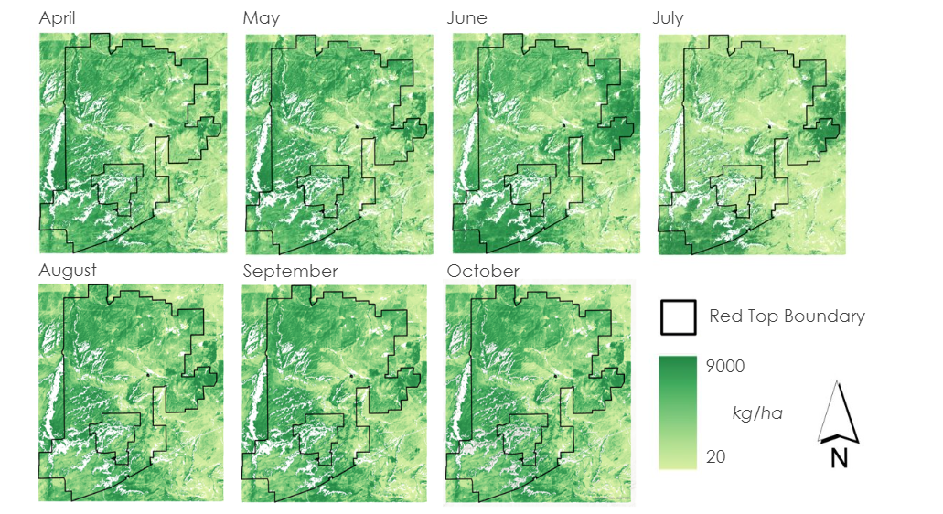

*Figure 4.* Monthly biomass maps using ARS 2022 data with all vegetation types masked except for Western Great Plains Shortgrass Prairie and Western Great Plains Foothill and Piedmont Grassland. Light yellow represents low biomass values and dark green represents high biomass values. The maps show monthly max biomass values per individual pixel.

The day of year map and graph showed that there is a peak in biomass in June through July, and then a smaller peak in late September (Figure 5). The peak in the summer months is as expected as most vegetation on the landscape is in full bloom. The second peak in the fall may be due to different vegetation blooming in cooler months, a late summer precipitation event or potentially snow skewing the biomass calculations. The map shows that the regions of the ranch that have higher daily biomass maximum values earlier in the year are on the eastern and southern sides. The eastern side of the ranch has higher biomass maximum values later in the year. A potential reason for this is the topography of the western regions contain higher elevations and hills with juniper stands, which may take longer to warm up for vegetation to grow.

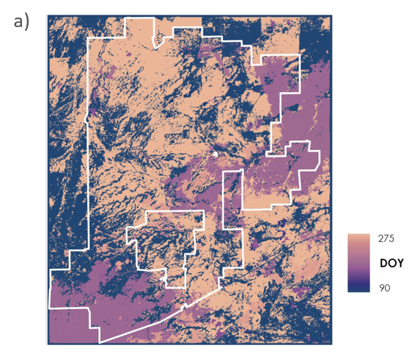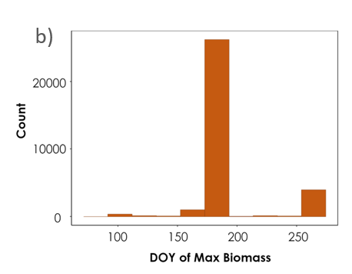

*Figure 5.*  a) Map of annual max biomass per pixel for 2022. The light orange represents max values that occurred in the later part of the growing season and the darker purple represents the earlier days closer to the beginning of the growing season in June. b.) Histogram of max biomass per pixel correlating with day of year max map.

The monthly maps show a pattern of higher biomass in the western part of the ranch within pastures of interest (Figure 6a). The graph shows that in 2022, Studebaker and Mayer pastures had noticeably higher numbers than the rest of the pastures. The control pastures vary in biomass, similarly to the experimental pastures. The control pastures have higher total biomass than the experimental pastures by 5,631,176 kilograms per hectare (Figure 6b). Even though the experiment was set up so that the control and experimental pastures were similar in vegetation and biomass amounts, it is not going to be exact. The observation that the control herds do have more biomass can be useful for improving the experimental design going forward.

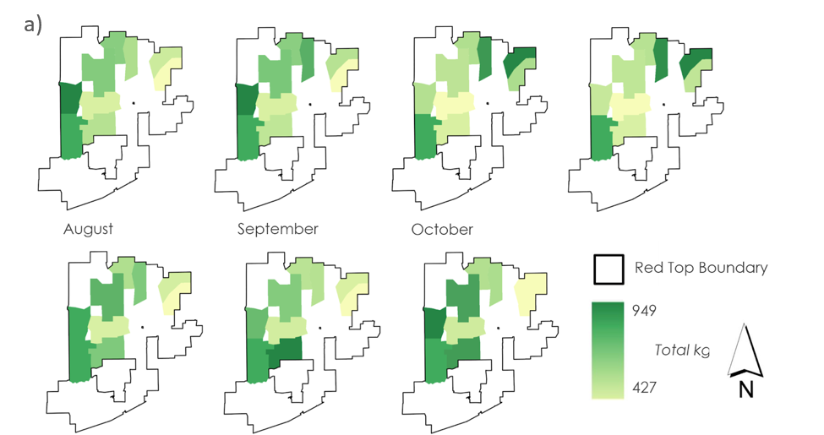

*Figure 6*. a.) Maps of max monthly biomass values in kilogram per hectare during the growing season of 2022.

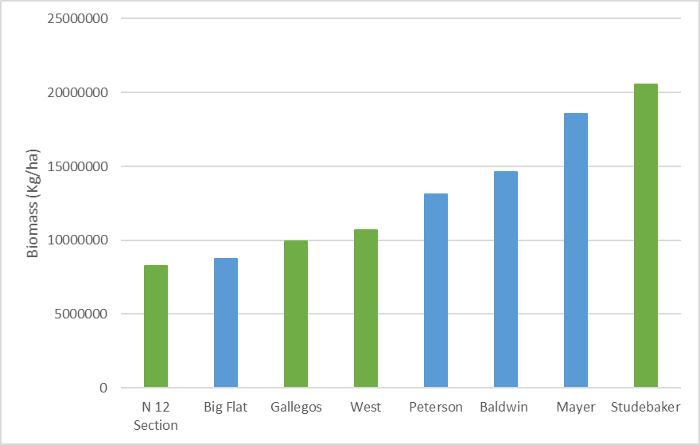b.) Graph of total biomass using annual max per pixel for the whole year of 2022, with vegetation mask applied. Experimental herds are shown in green (N 12, Studebaker, Gallegos, West). Control herds are shown in blue (Peterson, Big Flat, Mayer and Baldwin). The total annual biomass for the experimental herds were 49,417,143 kilograms per hectare and the control was 55,048,319.

We expected the ARS model-predicted biomass to have a stronger relationship with the visually-observed field data, however, there was not a statistically significant relationship (Figure 7). This may be due to the small sample size of field data that was sampled over only 28 plots and were in a relatively narrow range of biomass levels. An increase in field data samples may result in a comparison that is more representative of their relationship to each other. In addition, samples could be taken across a wider range of vegetation types and during different times throughout the year. Samples could be taken across years to examine the effects of wet and dry precipitation patterns.

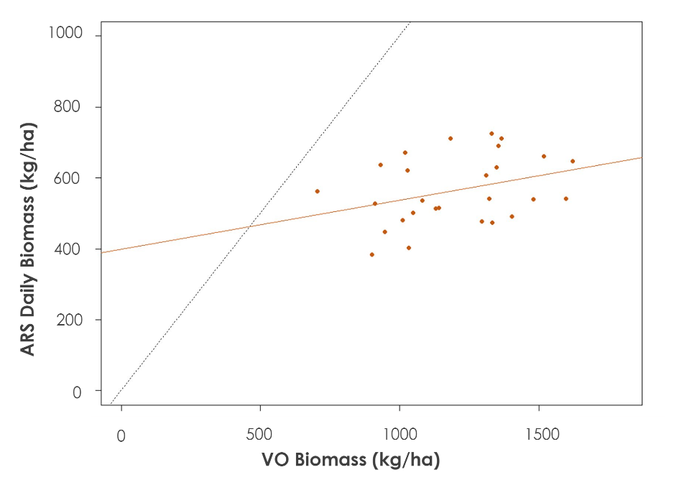

*Figure 7.* Graph of ARS daily biomass values compared to Visually Observed (VO) filed data for 2022. The R2 value was 0.08 and the P-value was 0.09. The dotted, gray line is the one-to-one line, and the orange line is the regression.

Annual RAP and mean annual ARS for 2021 had a weak relationship between each other (Figure 8). This may be due to the models being calibrated for different landscapes and varying vegetation types. Further, these values do not represent masked ARS values, and these may be influencing the relationship. The ARS biomass raster was calibrated for Northern Colorado whereas the RAP was calibrated for a wider region of the western United States. This comparison is not masked with our vegetation mask. Since Red Top Ranch contains different vegetation such as juniper trees, this may explain the high values in the ARS data. A mask can be applied to highlight only the vegetation cover of interest and then the models could be compared against each other again. Additionally, the 1:1 line goes through the highest density of points shown in yellow. This shows that there is the potential for a relationship between ARS and RAP.

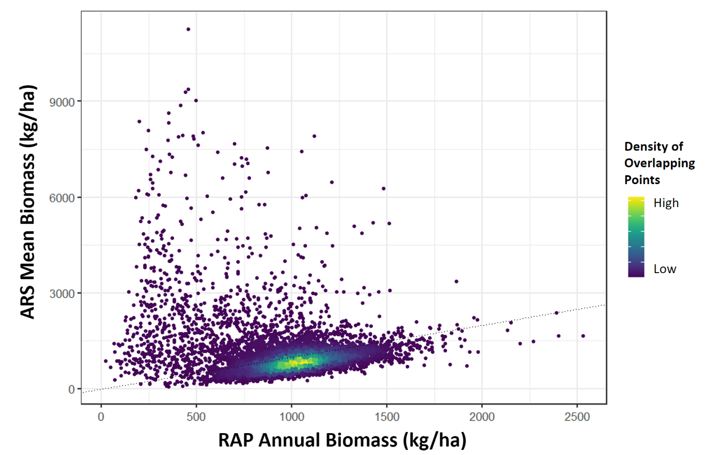

*Figure 8.* Graph comparing ARS mean annual Biomass to RAP annual biomass for 2021. Dotted line shows the 1:1 fit.

***4.2 Future Work***

This study provides an example of the use of remote sensing in combination with virtual fencing for rangeland management and monitoring experimental outcomes. To validate the model-predicted biomass, more field data can be collected over a wider range of conditions to provide more robust validation data for the ARS biomass predictions. This would include taking samples at more sites, during varying climatic conditions, variety of vegetation types, etc. Additionally, the spatial and temporal patterns of the biomass dataset created by the Rangeland Analysis Platform (RAP) can be explored further. The dataset has 16-day averaged biomass products that can be analyzed and applied to the landscape.

# 5. Conclusions

In this study, we explored the most recent annual and monthly biomass patterns for 2022. During this year, the biomass had some logical patterns across the landscape. There were higher biomass values on the western side of the ranch. Biomass increased during the summer months, with the exception of July, which warrants further investigation. The spatial and temporal patterns look reasonable for the landscape.

ARS has cover types that have biomass values outside of expected ranges, which may be due to its calibration on a landscape that does not have the same cover types that are found in our study area at Red Top Ranch. The algorithm used in the model was not trained to account for larger vegetation such as cholla cactus and juniper trees. We attempted to address this with the vegetation mask utilizing LANDFIRE existing vegetation types, however, LANDFIRE is calibrated at a national scale, and the class types are not specific enough to isolate vegetation species. The initial field validation was limited due to a small sample size of visually observed plots. RAP and ARS have a weak relationship between their biomass calculations with a p-value of 0.04. Increasing the sample size from the 27 plots to 10,000 randomly selected points did increase the significance of the relationship. The 1:1 line goes through the highest density of points, highlighting the potential for a more significant relationship if the high values of ARS are masked out. Since RAP did not have the high biomass outliers and is trained across the western United States, it may be better suited to address new cover types in future analysis.

# 

# 6. Acknowledgments

The Colorado Eastern Plains Agriculture Team thanks our project partners from The Nature Conservancy (TNC) and Red Top Ranch. We are grateful for our advisors at Colorado State University and the Natural Resource Ecology Laboratory, Christopher Tsz Hin Choi, Dr. Anthony Vorster, and Nicholas Young for providing guidance and support throughout our project term, and Peder Engelstad for providing technical assistance. We would also like to thank the Agricultural Research Service (ARS) for providing the data and methodology focused on in this project.

Any opinions, findings, and conclusions or recommendations expressed in this material are those of the author(s) and do not necessarily reflect the views of the National Aeronautics and Space Administration.

# 7. Glossary

**Earth observations** – Satellites and sensors that collect information about the Earth’s physical, chemical, and biological systems over space and time

**MODIS** – Moderate Resolution Imaging Spectroradiometer

**VO** – Visually Observed, referring to a method of field-sampling biomass

**RAP –** Rangeland Analysis Platform

**ARS** – Agricultural Research Service

**Robel Pole –** an instrument used to quantify standing biomass with line of sight.

# 8. References

Boyd, C.S., O’Connor, R.C., Ranches, J., Bohnert, D.W., Bates, J. D., Johnson, D.D., Davies, K.W., Parker,

T., Doherty, K.E. (2022) *Using Virtual Fencing to Create Fuel Breaks in the Sagebrush Steppe,* Rangeland

Ecology & Management. htt[ps://doi.org/10.1016/j.rama.2022.07.006](https://doi.org/10.1016/j.rama.2022.07.006).

Boyce, M. S., & McDonald, L. L. (1999). *Relating populations to habitats using resource selection functions.* Trends in

ecology & evolution, 14(7), 268-272.<https://doi.org/10.1016/S0169-5347(99)01593-1>

Campbell, D. L. M., Marini, D., Lea, J. M., Keshavarzi, H., Dyall, T. R., & Lee, C. (2021). *The application of*

*virtual fencing technology effectively herds cattle and sheep*. Animal Production Science, 61(13), 1393-1402.

<https://doi.org/10.1071/AN20525>

USDA Natural Resources Conservation Service. (2022) *Ecological site R069XY006CO Loamy Plains, LRU's A*

*and B 10-14 Inches, P.Z.* https://edit.jornada.nmsu.edu/catalogs/esd/069X/R069XY006CO

Jones, M.O., N.P. Robinson, D.E. Naugle, J.D. Maestas, M.C. Reeves, R.W. Lankston, and B.W. Allred.

(2021). *Annual and 16-day rangeland production estimates for the western United States.* Rangeland and

Ecology Management. 77(2021), 112-117. <https://doi.org/10.1016/j.rama.2021.04.003>

Kearney, S. P., Porensky, L. M., Augustine, D. J., Gaffney, R., & Derner, J. D. (2022). *Monitoring standing*

*herbaceous biomass and thresholds in semiarid rangelands from harmonized Landsat 8 and sentinel-2 imagery to*

*support within-season adaptive management*. Remote Sensing of Environment.

<https://doi.org/10.1016/j.rse.2022.112907>

Knight, Richard. (2009). *Ranchers as a Keystone Species in a West That Works*. Rangelands. 29. 4-9.

[https://doi.org/10.2111/1551-501X(2007)29[4:RAAKSI]2.0.CO;2](https://doi.org/10.2111/1551-501X(2007)29%5B4:RAAKSI%5D2.0.CO;2).

Robinson, N.P., M.O. Jones, A. Moreno, T.A. Erickson, D.E. Naugle, and B.W. Allred. (2019). *Rangeland*

*productivity partitioned to sub-pixel plant functional types.* Remote Sensing 11:1427.

<https://dx.doi.org/10.3390/rs11121427>